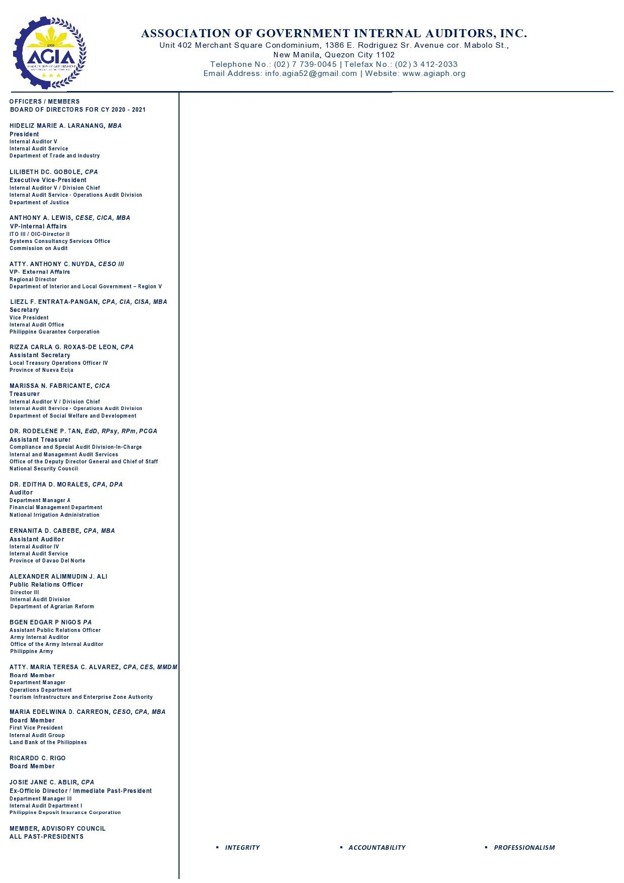
17 August 2021

______________________
______________________
______________________

Dear ________________:

Greetings!

We are inviting participants from your office to attend our on-line seminars or Webinars for the 4th Quarter of CY 2021 which are open not only to internal auditors but also to those who perform accounting, budgeting, procurement, risk management, disposal and other related administrative functions.

The seminars are part of AGIA’s commitment to assist government officials and employees to become more responsive and effective public servants in line with Memorandum Circular No. 89 dated August 18, 2005, and in compliance with Section 3 of Administrative Order No. 70 series of 2003, both issued by the Office of the President, mandating the AGIA to ensure that all internal audit works in all government agencies be conducted in conformity with the standards of the internal audit profession.

The AGIA is an Accredited Continuing Professional Development (CPD) Provider by the CPD Council for Accountancy issued by the Professional Regulation Commission, Accreditation No. 2009-022.

Inclusive Dates | Time | Course Title | No. Of Hours | Seminar Fee
October 7 – 8 | 8:30am-5:00pm | AGIA ANNUAL NATIONAL CONVENTION  Theme: “NAVIGATING THROUGH RISKS AND CHALLENGES UNDER THE NEW NORMAL” | 16 | 4,000.00
October 13 - 15 | 8am-5pm | CASH MANAGEMENT AND ITS INTERNAL CONTROL SYSTEM | 24 | 3,750.00
October 13 – 15 | 8am-5pm | GOVERNMENT PROCUREMENT REFORM ACT (R.A. 9184) AND ITS REVISED IRR AND UPDATES | 24 | 3,750.00
October 19 – 22 | 8am-12nn | THE PHILIPPINE BUDGETING SYSTEM | 16 | 2,500.00
October 20 – 22 | 8am-5pm | GUIDING PRINCIPLES ON THE MANAGEMENT OF GOVERNMENT FUNDS AND PROPERTIES (Laws, Rules and Regulations for Government Expenditures) | 24 | 3,750.00
October 26 – 29 | 8am-12nn | BASIC INTERNAL CONTROL CONCEPTS AND INTERNAL AUDITING PRINCIPLES AND PRACTICES | 16 | 2,500.00
October 27 – 29 | 8am-5pm | PREPARATION OF THE PROJECT PROCUREMENT MANAGEMENT PLAN (PPMP) AND THE ANNUAL PROCUREMENT PLAN(APP): Concepts, Principles and Techniques | 24 | 3,750.00
November 3 – 5 | 8am-5pm | ACCOUNTING POLICIES, GUIDELINES AND PROCEDURES FOR NATIONAL GOVERNMENT AGENCIES (NGAs) | 24 | 3,750.00
November 3 - 5 | 8am-5pm | INTERNAL CONTROL SYSTEM FOR PROPERTY AND SUPPLY MANAGEMENT  (Appraisal and Disposal) | 24 | 3,750.00

November 9 - 12 | 8am-12nn | INFORMATION SYSTEM AUDIT FUNDAMENTALS | 16 | 2,500.00
November 9 - 12 | 1pm-5pm | EFFECTIVE AUDIT REPORT WRITING | 16 | 2,500.00
November 10 - 12 | 8am-5pm | GOVERNMENT PROCUREMENT REFORM ACT (R.A. 9184) AND ITS REVISED IRR AND UPDATES | 24 | 3,750.00
November 16 - 18 | 8am-5pm | RISK MANAGEMENT | 24 | 3,750.00
November 17 - 19 | 8am-5pm | CASH MANAGEMENT AND ITS INTERNAL CONTROL SYSTEM | 24 | 3,750.00
November 23 - 26 | 8am-12nn | OPERATIONS AUDIT | 16 | 2,500.00
November 24 - 26 | 8am-5pm | THE PHILIPPINE BIDDING DOCUMENTS | 24 | 3,750.00
November 24 – 26 and December 2 – 3 | 8am-12nn | PRESENTATION AND FACILITATION SKILLS FOR INTERNAL AUDITORS | 20 | 3,125.00
December 1 – 3 | 8am-5pm | BASIC ACCOUNTING AND INTERNAL CONTROL FOR NON-ACCOUNTANTS | 24 | 3,750.00
December 1 – 3 | 8am-5pm | PREPARATION OF THE PROJECT PROCUREMENT MANAGEMENT PLAN (PPMP) AND THE ANNUAL PROCUREMENTPLAN (APP): Concepts, Principles and Techniques | 24 | 3,750.00
December 6 - 7 and  December 9 - 10 | 8am-12nn | MANAGEMENT AUDIT | 16 | 2,500.00
December 6 - 7 and 9 | 8am-5pm | INTERNAL CONTROL SYSTEM FOR PROPERTY ANDSUPPLY MANAGEMENT  (Appraisal and Disposal) | 24 | 3,750.00
December 14 - 17 | 8am-12nn | REMOTE AUDITING IN THE PUBLIC SECTOR | 16 | 2,500.00
December 15 - 17 | 8am-5pm | GOVERNMENT PROCUREMENT REFORM ACT (R.A. 9184) AND ITS REVISED IRR AND UPDATES | 24 | 3,750.00
December 15 - 17 | 8am-5pm | GUIDING PRINCIPLES ON THE MANAGEMENT OF GOVERNMENT FUNDS AND PROPERTIES (Laws, Rules and Regulations for Government Expenditures) | 24 | 3,750.00
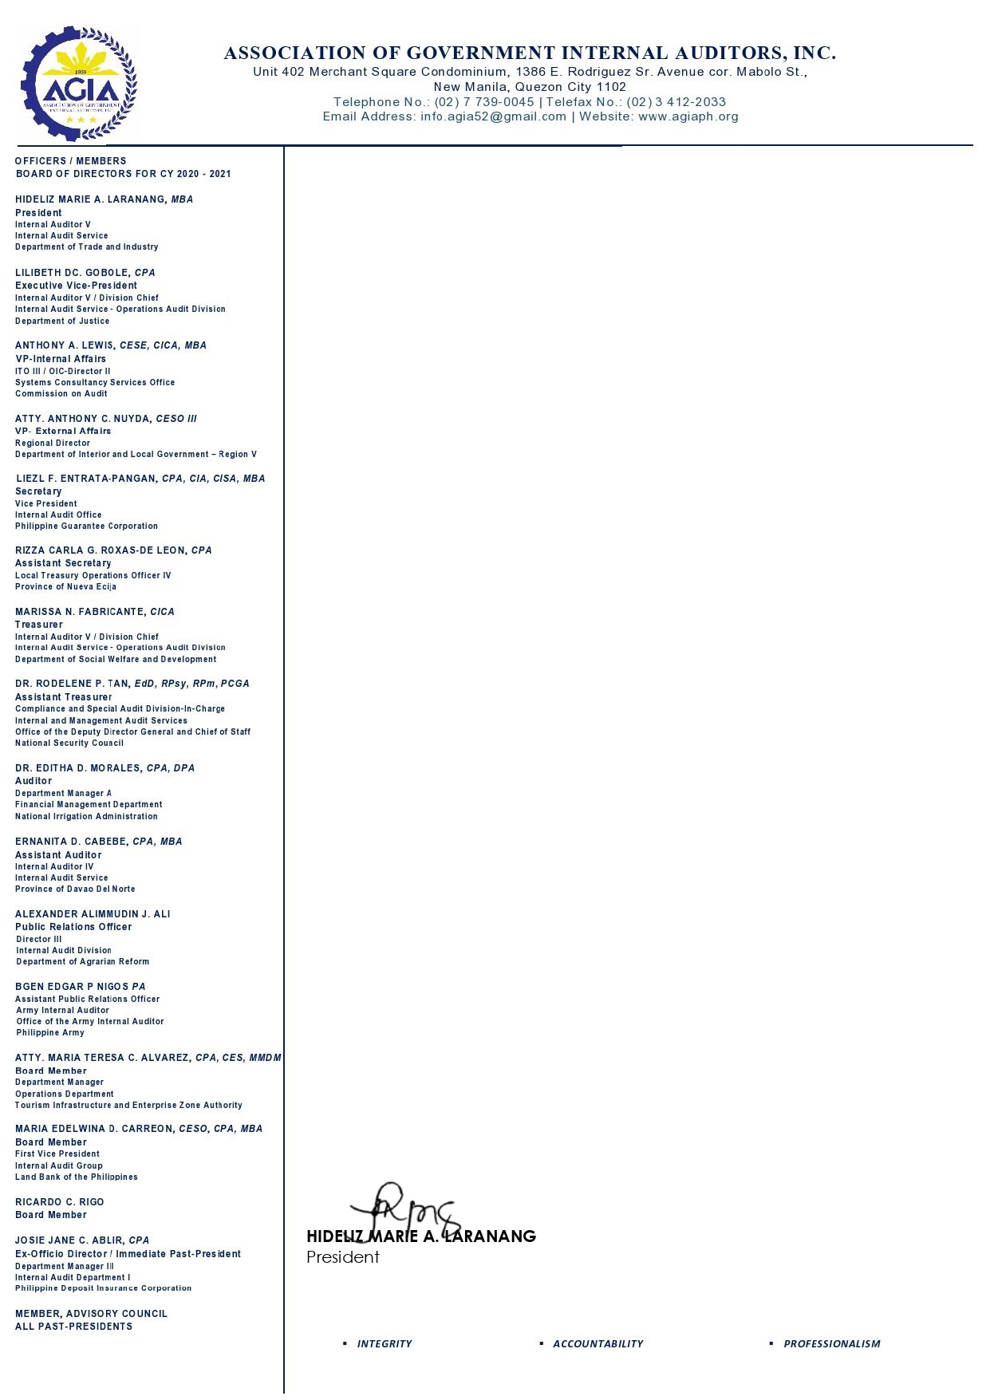

FOR ON-LINE REGISTRATION, please visit our website www.agiaph.org. We encourage early confirmation and payment. Those who have neither confirmed their participation nor rendered payment or without Agency’s Guarantee Letter on or before the seminar schedule will not be accommodated.

Very truly yours,

