Republic of the Philippines

Department of Environment and Natural Resources
MIMAROPA Region
PROVINCIAL ENVIRONMENT AND NATURAL RESOURCES OFFICE
Sta. Monica, Puerto Princesa City

June 23, 2021
MEMORANDUM

FOR : The Regional Executive Director
DENR MIMAROPA Region
1515 L & S Building
Roxas Blvd., Ermita Manila

THRU : The Assistant Regional Director for
Management Services

ATTENTION : The Chief, Planning and Management Division

FROM : The Provincial Environment and
Natural Resources Officer
DENR-PENRO, Sta. Monica
Puerto Princesa City

SUBJECT : JUSTIFICATION ON THE REQUEST FOR TRANSFER
OF TARGETS ON FORESHORE APPRAISAL AND
RE-APPRAISAL OF PALAWAN.

Respectfully forwarded is the Memorandum of CENRO Brooke’s Point and CENRO Coron, Palawan dated January 29, 2021 (previously emailed as attachment to our Justification early this year) and June 16, 2021 respectively regarding on the above subject.

With the reasons mentioned in both Memoranda, we are requesting for possible reduction of our targets on the said activities (Appraisal from 30 to 20 and Re-appraisal from 14 to 7), since we cannot transfer the same to other CENROs which are also having difficulties in complying the requirements of the foreshore Appraisal and Re-Appraisal in accordance with the Memorandum of Acting LMB Director Atty. Emelyne V. Talabis.

Please be informed further, that these justifications having presented to that office several times. Hence, we are need immediate response for our guidance and possible course of action to do considering the remaining months to accomplish the said targets.

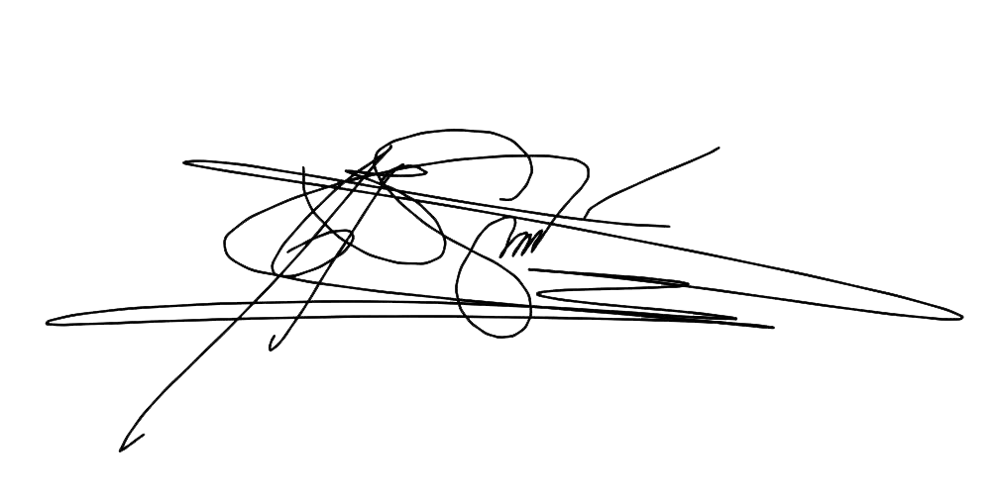
For information and consideration.

ERIBERTO B. SAÑOS, CESE

