September 13, 2021

MEMORANDUM

FOR : The OIC, PENR Officer

THRU : The Chief, Technical Services Division

FROM : The CEMEMP-Monitoring and Evaluation Officer
QUARTERLY PROGRESS REPORT ON THE COASTAL AND MARINE ECOSYSTEM MANAGEMENT PROGRAM OF CENRO SABLAYAN FOR THE 4th QUARTER OF CY 2021
SUBJECT :

- SABLAYAN-CALINTAAN MARINE PROTECTED AREA NETWORK (SaCa MPAN) MANAGEMENT BOARD MEETINGHELD SABLAYAN, OCCIDENTAL MINDORO ON NOVEMBER 5, 2021

The SaCa MPAN Management Board in facilitation of CENRO Sablayan and San Jose conducted meeting at LANDMANZ Hotel and Restaurant, Sablayan, Occidental Mindoro last November 5, 2021. The said activity was attended and participated by representatives from DENR-PENRO Occidental Mindoro, DENR- CENRO Sablayan, Occidental Mindoro, DENR- CENRO San Jose, Occidental Mindoro, LGU Sablayan, Occidental Mindoro, LGU Calintaan, Occidental Mindoro.

- DENR-CENRO CONSERVATION OF WILDLIFE RESOURCES (HABITAT MONITORING)

The DENR-CENRO Sablayan have written a letter to the concern LGU’s of Sto. Niño, Buenavista, Poblacion, Sta. Lucia, Gen. Emilio Aguinaldo and Burgos as coordination for the conduct of inventory and monitoring of marine turtle nesting sites and their habitats. There will be a brief workshop for the proper handling and disposition of rescued/stranded marine turtle. The DENR-CENRO have also prepared laminated guides to help the peoples in the area.

- WATER QUALITY MONITORING

Five sampling sites were established this year as per PAMB Resolution No. 2021-01. Four of which were sampled for surface water. Three of these sites are located along the bathing beach in Apo Island. It was ensured that the three sites were at least 300 meters away from each other as recommended in the EMN Water Quality Monitoring Manual. These sites were selected because they are areas with high tourist traffic. Thus, it is important to assess the safety of these sites for human recreation. As well as the possible impacts of the tourism on water quality. This is the same for the well-known dive site, Ego Wall.

The Apo Reef National Park-Protected Area Management Office (ARNP-PAMO) have conducted water quality monitoring in the mentioned sites during wet season of 2021. Report will be submitted on the first week of December 2021

- INTERNATION COASTAL CLEAN-UP

The Community Environment and Natural Resources Office – Sablayan have participated the International Coastal Clean-up for the CY 2021.

Reports and follow-up activities are to be conducted before end of the CY 2021

For your information, record and further instruction.

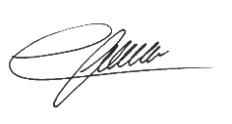

EFREN A. GRABILLO

PHOTO DOCUMENTATION

MARINE PROTECTED AREA NETWORKING
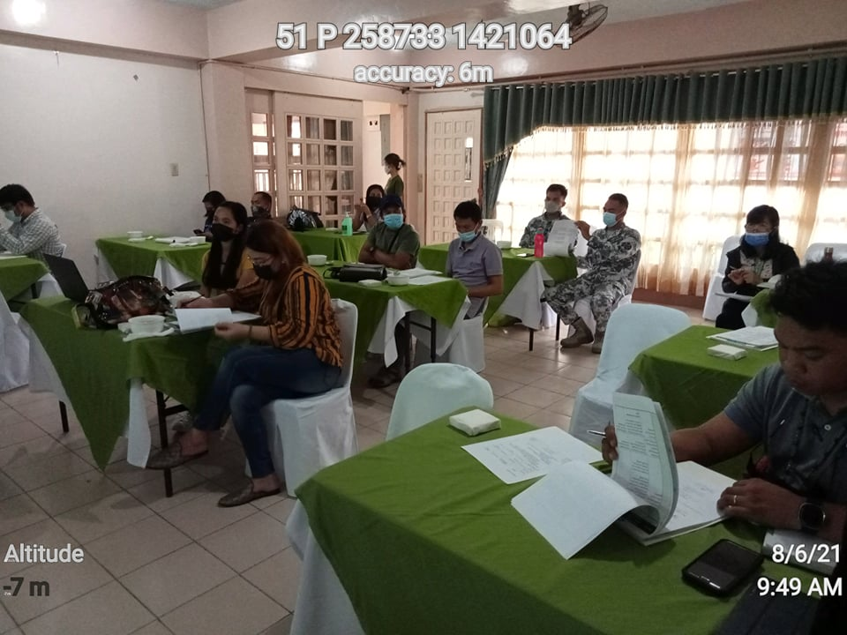
NOVEMBER 5, 2021

