
Republic of the Philippines
MIMAROPA Region
Department of Environment and Natural Resources
Provincial Environment and Natural Resources Office
LEGAL DIVISION MIMAROPA @ PENRO - PALAWAN
Sta. Monica, Puerto Princesa City

MEMORANDUM:
FOR : THE REGIONAL EXECUTIVE DIRECTOR (RED)
MARIA LOURDES G. FERRER, CESO III

FROM : ATTY. LILLIBETH MARY ELVISA S. ABIOG
Legal Division, Region MIMAROPA @ PENRO, PALAWAN

cc : The Chief, Legal Division
Region MIMAROPA @ 1515 L&S Building, Roxas Boulevard, Metro Manila

DATE : April 16, 2021

SUBJECT : MEMORANDUM DATED APRIL 15, 2021 IN RELATION TO UNNUMBERED MEMORANDUM DATED DECEMBER 28, 2020 ON THE SUBJECT OF SALN

Reference Docs: The RED’s Memorandum dated April 15, 2021 to LILLIBETH MARY ELVISA S. ABIOG RE: SALN
The RED’s Memorandum dated December 28, 2020 on the Subject of SALN.

The undersigned employee received on April 16, 2021 a copy of the Memorandum of the Honorable RED Maria Lourdes G. Ferrer, CESO III, calling the attention of the undersigned to the Memorandum dated December 28, 2020 regarding the submission of the Statement of Assets and Liabilities and Net Worth (SALN), which according to Section 8 of Republic Act No. 6713 must be submitted by April 30 of each year. A copy of the said Memorandum of the RED dated December 28, 2020 was also received by the undersigned on April 16, 2021.
The undersigned submitted her SALN for the years 2017, 2018, and 2019, to the Civil Service Commission (CSC), through the Human Resources Division of the MIMAROPA, and up to this date, she has yet to receive her CSC stamped-received copies of her SALN for each of the years involved.
On this basis, the undersigned endeavors to finish preparing her SALN for timely submission by April 30, 2021 to the Civil Service Commission, channeled through the Human Resources Division, within a reasonable time of one week before final submission to the Civil Service Commission, without being disrespectful to and without any disregard for the authority of the Regional Executive Director in properly discharging her functions.
Thank you for the very kind consideration.
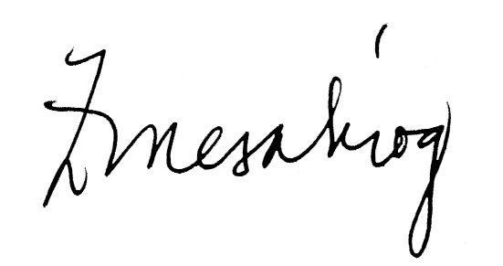
LILLIBETH MARY ELVISA S. ABIOG
Attorney II

LILLIBETH M.E. S. ABIOG
Attorney

