Republic of the Philippines
Office of the Chairman and consultant
Pleasant village, Manggahan pasig city
Email: defino.condes.secretariatoffice@gmail.com
Contact no: 09656413620/02-87417017

December 15, 2022

To Lormelyn cloudio
DENR mimaropa regional director

Dear sir

Greetings to you, please send an order to DENR odiongan to hold relocation survey based on my petition sent to your office under Domingo condes title parcel of land at sitio tipolo sta. Fe romblon. please reply immediately DENR odiongan waiting for your personal memorandum from your regional office.

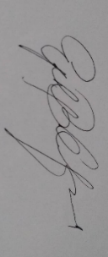
Respectfully yours

Hon. NinoyDefino
Consultant

