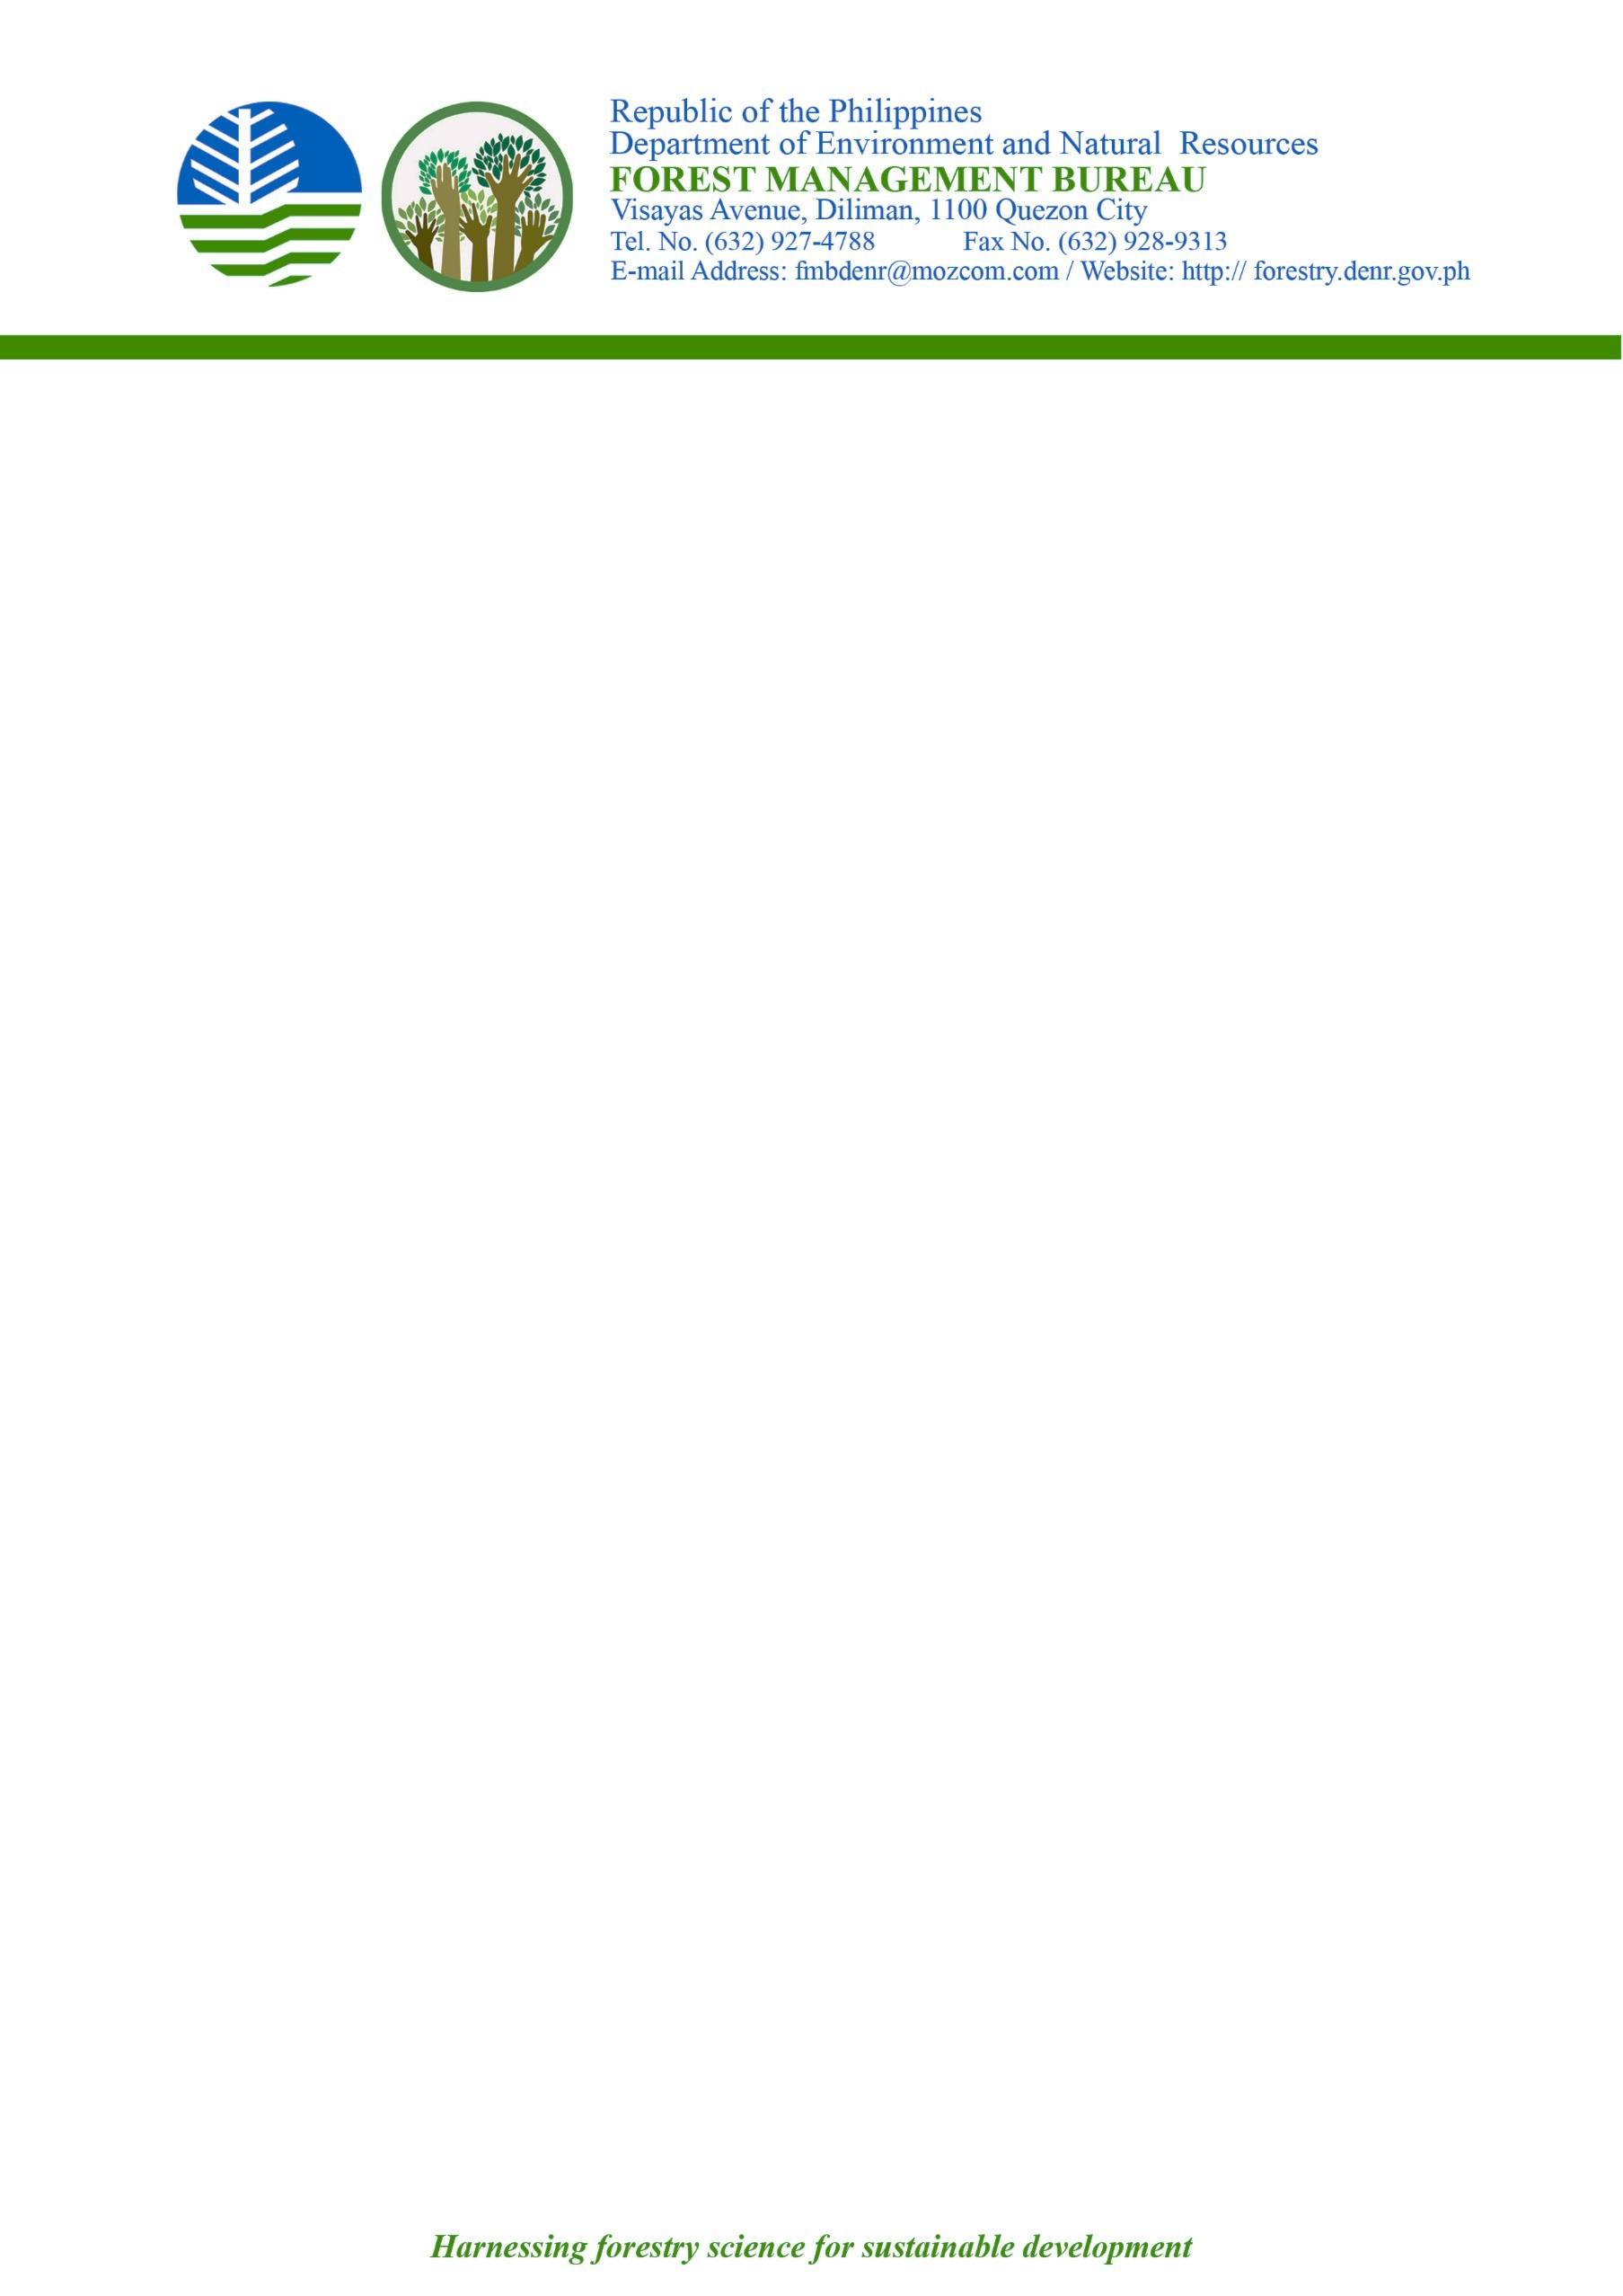
8

ACKNOWLEDGEMENT RECEIPT

DATE | : | 20 December 2022
DOCUMENT CODE | : | 2147564022
NAE | : | DIR. LORMELYN E. CLAUDIO, CESO IV  Regional Executive Director, DENR RIV-B (MIMAROPA)
ADDRESS | : | DENR R4B, 1515 L & S Building, Roxas Boulevard, Ermita, Manila
This is to acknowledge the receipt of:

SUBJECT | : | CSW Report re: (1) Email Complaint of Ms. Helly Y Asoy on the Alleged Construction of a Roadway and Bunkhouses Adjacent to a Coastal Area located in Brgy. Taclobo, San Fernando, Romblon; (2) Letter Complaint of Mr. Ireneo Rafol Romano et al. on the Alleged Illegal Extraction of Nickel, Gold and Illegal Logging Activities in Sibuyan Island, Romblon [E-2022-92700]
The said document was referred to the Office of the Director on December 20, 2022. You may follow up further action or development on the matter through contact no. (63-2) 8928-9313 / 8927-4788.

Note: This is a computer-generated communication. As such, no signature is required.

