08 March 2022

______________________
______________________
______________________

Dear ________________:

Greetings!

We are inviting participants from your office to attend our on-line seminars or Webinars for the 2nd Quarter of CY 2022 which are open not only to internal auditors but also to those who perform accounting, budgeting, procurement, risk management, disposal and other related administrative functions.

The seminars are part of AGIA’s commitment to assist government officials and employees to become more responsive and effective public servants in line with Memorandum Circular No. 89 dated August 18, 2005, and in compliance with Section 3 of Administrative Order No. 70 series of 2003, both issued by the Office of the President, mandating the AGIA to ensure that all internal audit works in all government agencies be conducted in conformity with the standards of the internal audit profession.

The AGIA is an Accredited Continuing Professional Development (CPD) Provider by the CPD Council for Accountancy issued by the Professional Regulation Commission, Accreditation No. 2009-022.

Inclusive Dates | Time | Course Title | No. Of Hours | Seminar Fee
April 4 – 8 | 8am-12nn | GOVERNMENT PROCUREMENT REFORM ACT (R.A. 9184) AND ITS REVISED IRR AND UPDATES | 20 | 3,125.00
April 6 – 8 | 8am-5pm | GUIDING PRINCIPLES ON THE MANAGEMENT OF GOVERNMENT FUNDS AND PROPERTIES (Laws, Rules and Regulations for Government Expenditures) | 24 | 3,750.00
April 18 – 21 | 8am-12nn | STRATEGIC AND OPERATIONS PLANNING | 16 | 2,500.00
April 18 – 21 | 8am-12nn | BASIC INTERNAL CONTROL CONCEPTS AND INTERNAL AUDITING PRINCIPLES AND PRACTICES | 16 | 2,500.00
April 26 – 28 | 8am-5pm | ACCOUNTING POLICIES, GUIDELINES AND PROCEDURES FOR NATIONAL GOVERNMENT AGENCIES (NGAs) | 24 | 3,750.00
April 26 – 28 | 8am-12nn | OPERATIONS AUDIT | 24 | 2,500.00
May 4 – 6 | 8am-5pm | CASH MANAGEMENT AND ITS INTERNAL CONTROL SYSTEM | 24 | 3,750.00
May 4 – 6 | 8am-5pm | PHILIPPINE GOVERNMENT ACCOUNTING STANDARDS | 24 | 3,750.00
May 9 – 13 | 8am-12nn | GOVERNMENT PROCUREMENT REFORM ACT (R.A. 9184) AND ITS REVISED IRR AND UPDATES | 20 | 3,125.00

May 11 – 13 | 8am-5pm | BASIC ACCOUNTING AND INTERNAL CONTROL FOR NON-ACCOUNTANTS | 24 | 3,750.00
May 17 – 20 | 8am-12nn | EFFECTIVE AUDIT REPORT WRITING | 16 | 2,500.00
May 18 – 20 | 8am-5pm | THE PHILIPPINE BIDDING DOCUMENTS  (Participants must have attended RA 9184) | 24 | 3,750.00
May 24 – 27 | 8am-12nn | INTERNAL AUDITOR’S WORKPLACE JOURNEY OF EMPOWERMENT | 16 | 2,500.00
May 25 – 27 | 8am-5pm | PREPARATION OF THE PROJECT PROCUREMENT MANAGEMENT PLAN (PPMP) AND THE ANNUAL PROCUREMENT PLAN(APP): Concepts, Principles and Techniques | 24 | 3,750.00
May 31 – June 3 | 8am-12nn | THE PHILIPPINE BUDGETING SYSTEM | 16 | 2,500.00
June 1 - 3 | 8am-5pm | RISK MANAGEMENT | 24 | 3,750.00
June 6 - 10 | 8am-12nn | GOVERNMENT PROCUREMENT REFORM ACT (R.A. 9184) AND ITS REVISED IRR AND UPDATES | 20 | 3,125.00
June 8 - 10 | 8am-5pm | ACCOUNTING POLICIES, GUIDELINES AND PROCEDURES FOR NATIONAL GOVERNMENT AGENCIES (NGAs) | 24 | 3,750.00
June 14 - 17 | 8am-12nn | TOOLS AND TECHNIQUES FOR INTERNAL AUDITING | 16 | 2,500.00
June 15 - 17 | 8am-5pm | GUIDING PRINCIPLES ON THE MANAGEMENT OF GOVERNMENT FUNDS AND PROPERTIES (Laws, Rules and Regulations for Government Expenditures) | 24 | 3,750.00
June 21 - 24 | 8am-12nn | MANAGEMENT AUDIT | 16 | 2,500.00
June 22 - 24 | 8am-5pm | CASH MANAGEMENT AND ITS INTERNAL CONTROL SYSTEM | 24 | 3,750.00
June 27 - 30 | 8am-12nn | PROJECT MANAGEMENT AUDIT | 16 | 2,500.00
June 28 - 30 | 8am-5pm | INTERNAL CONTROL SYSTEM FOR PROPERTY AND SUPPLY MANAGEMENT  (Appraisal and Disposal) | 24 | 3,750.00

FOR ON-LINE REGISTRATION, please visit our website www.agiaph.org. We encourage early confirmation and payment. Those who have neither confirmed their participation nor rendered payment or without Agency’s Guarantee Letter on or before the seminar schedule will not be accommodated.

Very truly yours,

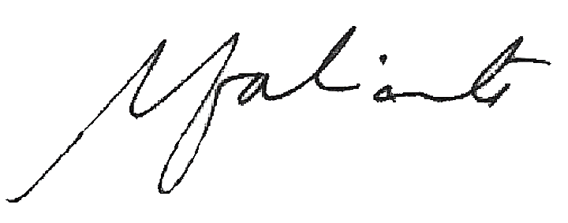

MARISSA N. FABRICANTE, CICA
President

