19 April 2022

______________________
______________________
______________________

Dear ________________:

Greetings from the Association of Government Internal Auditors, (AGIA) Inc.!
The Association of Government Internal Auditors (AGIA), Inc. will be holding its 2nd Government Internal Auditors Summit on June 8-10, 2022 from 8:00am to 12:00nn with the theme: “Revitalizing the Role of Internal Auditors in Today’s Dynamic Setting”. The Virtual Summit aims to highlight the current government internal auditing landscape and will focus on key tools and skills that Internal Auditors can use to boost their adaptability in this active and changing environment. Also, participants can look forward to discovering tools and resources to enhance work processes through internal auditing strategies that will be shared by our panel of speakers.
We have invited distinguished resource speakers to discuss topics on the latest tools and most effective strategies that can be adopted by the participants in performing audits in this time of pandemic. It is the AGIA’s desire to provide support for the internal audits of the government in continuously adding value to their respective organizations despite the present challenges.
The Registration Fee is Three Thousand Five Hundred Pesos (P3,500.00) and we appreciate if online registration can be done early on this link: https://tinyurl.com/aGIASummit2021. For non-members, we enjoin you to apply for AGIA membership upon your participation to the GIA Summit since you are entitled to a 50% discount on the Membership Fee.
For more information, please contact Ms. Renelyn Judilla at 09171800389 or visit our website www.agiaph.org and Facebook Page @AGIAPhilippines.
Thank you.
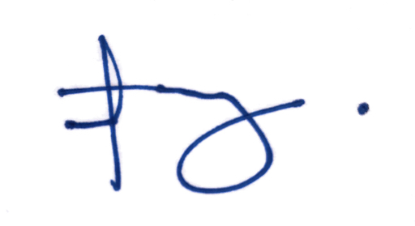
Very respectfully yours,
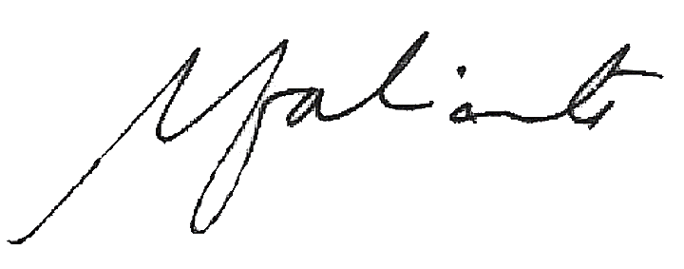

MA. VENE R. TACUBOY MARISSA N. FABRICANTE
2022 Summit Chairperson President

