COMMITTEE ON AGRICULTURE & FOOD
3rd Flr., Ramon V. Mitra Building, Batasan Complex, Quezon City
Tel Nos : (+632) 931-5001 loc. 7139 Telefax : (+632) 951-4400
Email Address: agriculturenfood@gmail.com
__________________________________________________________________

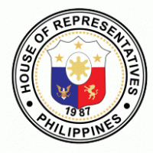
01 August 2023

SECRETARY MARIA ANTONIA YULO LOYZAGA
Department of Environment and Natural Resources

Dear Secretary Loyzaga:

The Committee on Agriculture and Food will hold a meeting on 07 August 2023, 9:30 A.M. at Conference Rooms 3 & 4 RVM Building, House of Representatives, Batasan Hills, Quezon City, for the consideration and approval of the Proposed Substitute Bill on the Establishment of a National Program for the Development of the Philippine Cacao Industry in substitution to House Bill Nos. 1370, 1411, 2931, 3546, and 6591.
Your participation in the meeting will be highly appreciated as your inputs will greatly help the Committee in its deliberation. Attached are copies of the proposed substitute bill and House Bill No. 3489 for your reference.
Thank you.

Very truly yours,

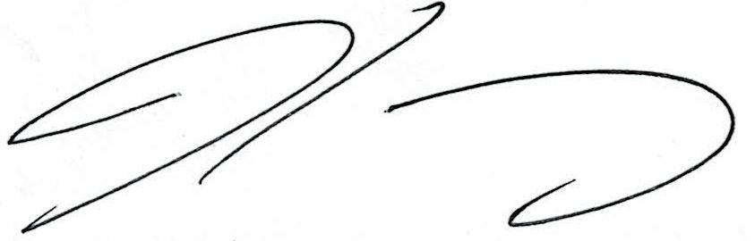
REP. WILFRIDO MARK M. ENVERGA

Chairperson

