November 14, 2023

HON. MARIA ANTONIA YULO LOYZAGA
Secretary
Department of Environment and Natural Resources
Visayas Avenue, Diliman, Quezon City

Dear Secretary Loyzaga:

We wish to inform you that the Committee on Climate Change of the House of Representatives will hold a Regular Meeting on November 21, 2023 (Tuesday), 9:00 A.M. at Speaker Belmonte Hall, South Wing Annex Building.

In line with this, we would like to invite you to a fruitful discussion and to share your valuable insights and comments during the meeting.

Our meeting is face-to-face; hence, we look forward to the submission of your confirmed attendees for advance coordination with the Office of the Sergeant-at-Arms for your entry to the House premises. Kindly email it through committee.climatechange@house.gov.ph on or before November 17, 2023.

We have attached herewith the agenda and the electronic copy of HR 1024 for your easy reference.

Should you need more information, please contact the Committee Secretary at 09277193534 or Ms. MeAnne Ordovez at 09154448595.

Thank you and we look forward to seeing and hearing from you at the meeting.

Very truly yours,

HON. EDGAR M. CHATTO
Chairperson

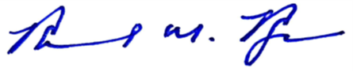
For the Chairperson:

ROMMEL M. REYES
Committee Secretary

