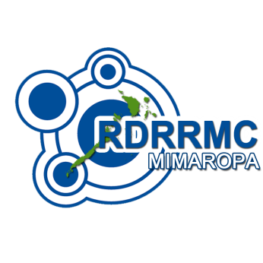
Republic of the Philippines
DEPARTMENT OF NATIONAL DEFENSE
Office of Civil Defense
Regional Disaster Risk Reduction and Management Council


OCD Regional Office MIMAROPA, PEO Compound, Kumintang Ilaya, Batangas City

[043] 723 4248 email: ocd4_mimaropa@yahoo.com

Activation and Organization Meeting of PDNA Team for Oil Spill Incident in Oriental Mindoro
25 October 2023

CONFIRMATION SLIP

NAME OF ATTENDEE | OFFICE / AGENCY | DESIGNATION | CONTACT NUMBER

